8.0 Digital to Physical:

The task that was given was to convert an originally digital based game into a physical tabletop game.

8.1 The Game:

The chosen game to convert was Grand Theft Auto. Primarily, a heist players get to participate throughout the game.

8.2 Materials:

* Gameboard
* D6 dice
* Pen and paper for lives (recommended)
* Player and enemy pieces

8.3 Rules:

* All players will use D6 dice to move around the board and fight enemies.
* Players all share 3 lives
* Players can only pick up one type of each weapon
* If there are 0 lives, then the game is lost even if there are still players on the board
* When on a square with a camera, players must move one space back

8.4 Gameplay:

Players would roll the dice to move from one end of the board to the other where the goal was located. Scattered amongst the board were several enemies that players would go up against, as well as various weapons to aid them in combat.

Weapons range from knives to bombs, with each type having a higher percentage of winning than the last.

When fighting enemies, players must roll the dice and if the number that it totals was the winning numbers for the weapon, then players can proceed with the game. However if they lose the battle the entire team loses a life, similar to how in the actual game of GTA players shared lives amongst them rather than having individual ones. The game ends once all players reach the goal.

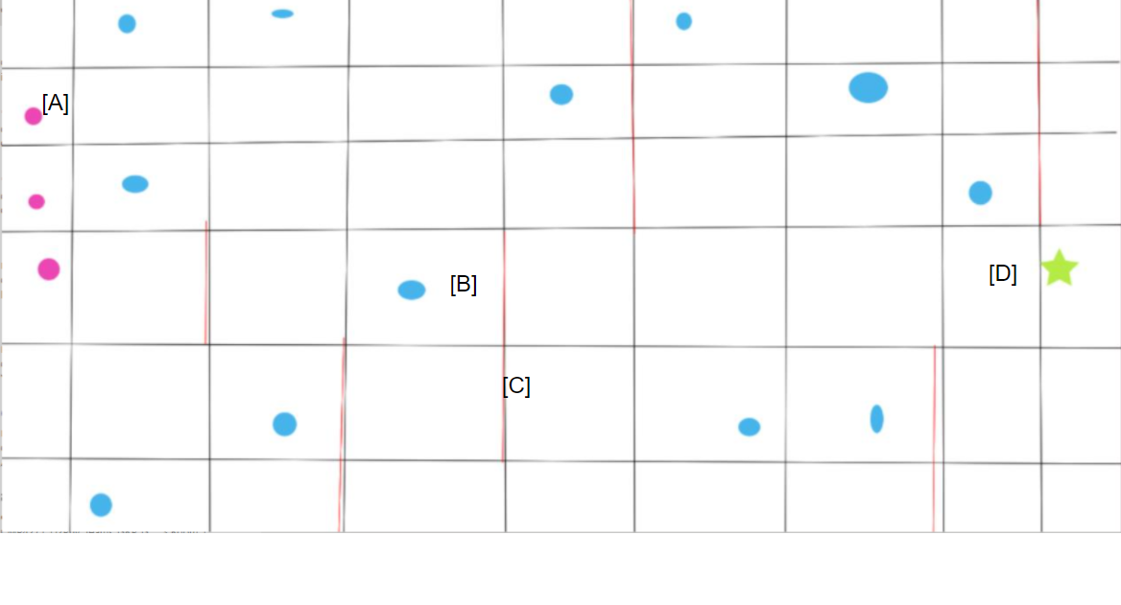

Figure 1. Prototype Gameboard. [A] are players that start at one end of the board. [B] are the enemies. [C] represents walls which block players from progressing, [D] is the goal.

8.5 Playtesting:

There was a chance to conduct some play testing with a player using the prototype board. According to their feedback there were too many enemies on the board, making it difficult to clear the game. Another problem with the game was that the walls were difficult to see in the prototype.

Acting on this, the board was given a redesign with much more clearer walls and reduced enemies as well as adding on the cameras and the weapons as part of the board.

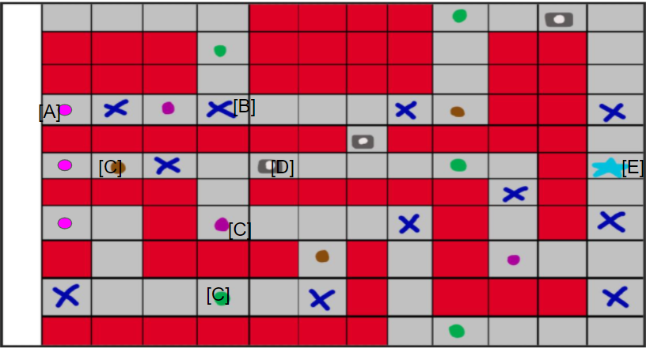

Figure 2. Final Gameboard. The walls are more defined. Weapons [C] as well as cameras [D] are now visually shown. Meanwhile players [A], enemies [B] and the goal [E] are still relatively the same as in the prototype.

8.6 Experience and Reflection:

At the start of the task, the team took some time deciding on a game, because everyone was drawing blanks on what games could be converted into physical games. But once it was decided, a discussion on the mechanics took most of the time, as there were problems when it came to adapting GTA’s heists into a board game. Such as the combat or the need for extra loot.

In order to create the game in time, it was decided that it was best to start on the game anyways and just fix errors in the mechanics along the way. By doing this, it saved time since basic principles were already established, while errors like the gameboard’s design were fixed in tangent with creating the powerpoint.

Although everything was done to a good standard there was a certain lack of time management because the discussion took up most of the time and there was little room to proofread the presentation or conduct multiple test plays to grant diverse or accurate feedback.

8.7 Members and Participants:

Jessica Evans

Reece Taylor

Giancarlo Trinidad

Ali Noorani - Test Player